Project Design Phase
Monitoring and Optimization Plan (Supplementary)
Date | 28 October 2026
Team ID | To Be Confirmed
Project Name | HotelPro – Hotel Management System
Maximum Marks | Supplementary
Document Status | Draft v1.0 – prepared from the stated HotelPro requirements. No HotelPro source code has been provided or verified, so all features are marked Planned.

1. Introduction
This plan lists the monitoring, analytics and optimisation measures proposed for HotelPro. Items are classified as Core (planned for release), Optional or Future. No measure is claimed to be in place; no performance numbers are reported because no measurements have been taken (Pending).

2. Optimisation Measures
Table 1: Optimisation measures
Area | Measure | Class | Status
Database indexing | Create indexes listed in the Database Design (availability, history, search); validate using explain() | Core | Planned
Query optimisation | Use projections, lean() reads for lists, pagination and aggregation pipelines for reports; avoid N+1 population | Core | Planned
API optimisation | Response compression, pagination limits, consistent field selection, rate limiting | Core | Planned
API caching | Cache read-mostly data (hotel info, categories) in memory or Redis | Optional | Not Yet Implemented
Frontend performance | Code splitting (React.lazy), lazy-loaded images, memoisation, debounced search input, production build | Core | Planned
Image optimisation | Resize/compress uploads; serve responsive sizes; use CDN | Optional | Planned
Logging | Structured request/error logs (e.g., morgan + a logger) and audit logs in adminlogs | Core | Planned
Error monitoring | Centralised error tracking and uptime checks via a hosted service (TBC) | Optional | Not Yet Implemented
Cloud deployment | Host frontend (static), API (Node) and MongoDB Atlas | Core | Planned
CDN | Serve static assets and images from a CDN | Optional | Not Yet Implemented
Load balancing | Run multiple stateless API instances behind a load balancer | Future | Not Yet Implemented
Scalability | Database replica set, read scaling, background job queue for emails and reports | Future | Not Yet Implemented
Backups | Scheduled database backups and tested restore | Core | Planned

3. Booking, Occupancy and Revenue Analytics
Table 2: Analytics metrics
Metric | Definition | Source Collections
Occupancy rate | Occupied room-nights ÷ available room-nights × 100 | bookings, checkinouts, rooms
ADR (Average Daily Rate) | Room revenue ÷ occupied room-nights | bookings, payments
RevPAR | Room revenue ÷ available room-nights (= occupancy × ADR) | bookings, payments, rooms
Bookings by status / channel | Count of bookings grouped by status and creator (online vs walk-in) | bookings
Cancellation rate | Cancelled bookings ÷ total bookings | bookings
Payment success rate | Paid ÷ attempted payments | payments
Average rating | Mean of review ratings per hotel | reviews

Reports are computed with MongoDB aggregation pipelines over indexed date ranges and displayed as charts (FR-A4, FR-M6). Computed values must be checked against hand-calculated samples during testing.

4. Monitoring Plan
Table 3: Monitoring plan
What to Monitor | How | Alert / Review (proposed)
API availability and latency | Health endpoint + uptime monitor; request logs | Review p95 latency per sprint; alert on downtime
Error rate | Error logs and status-code counts | Investigate spikes in 5xx
Payment/webhook failures | payments with FAILED/PENDING age; webhook error logs | Daily review during testing
Security events | adminlogs (failed logins, role changes) | Admin review weekly
Database performance | Atlas/Compass profiler; slow-query log | Review slow queries before release
Email delivery | notifications.emailStatus | Retry failed emails

5. Deployment and Scalability View
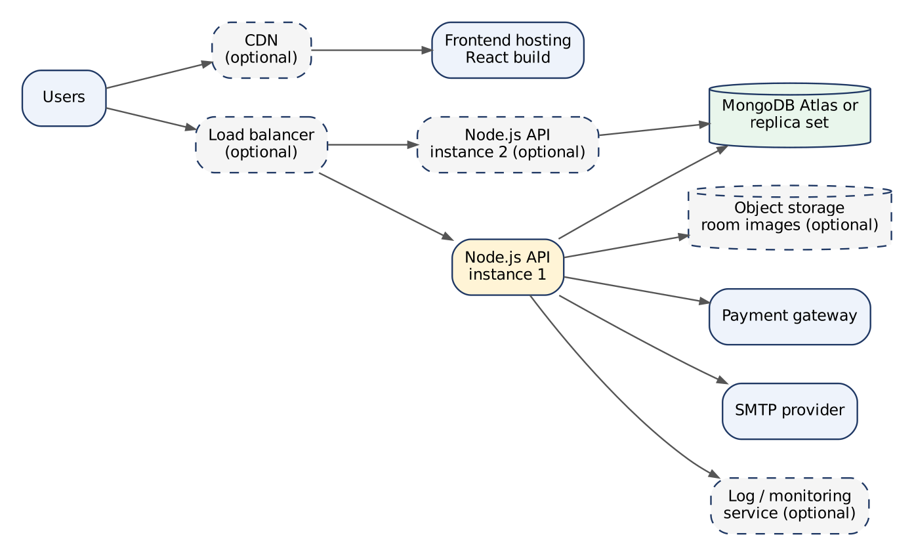
Figure 1: Planned deployment and scaling options (dashed = optional / future)

6. Performance Targets and Measurement
The following targets are goals to be validated; results are Pending until measured.
Table 4: Performance targets
Metric | Target | Measured Result | Tool (proposed)
Room search API p95 | < 500 ms with seed data of (volume TBC) | Pending | Postman / k6 / autocannon
Booking creation p95 | < 800 ms | Pending | Same
Frontend load (Largest Contentful Paint) | < 2.5 s on broadband | Pending | Lighthouse
Concurrent users supported | Target To Be Confirmed | Pending | k6

References
- MongoDB Performance Best Practices – https://www.mongodb.com/docs/manual/administration/analyzing-mongodb-performance/
- Express Performance Best Practices – https://expressjs.com/en/advanced/best-practice-performance.html
- React – Code Splitting – https://react.dev/reference/react/lazy
- Lighthouse – https://developer.chrome.com/docs/lighthouse/overview
- MongoDB Aggregation – https://www.mongodb.com/docs/manual/aggregation/

